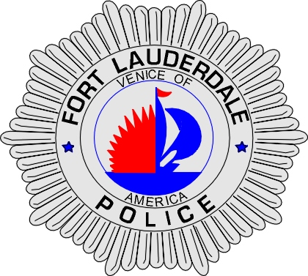 | CITY OF  FORT LAUDERDALE  POLICE DEPARTMENT  PRESS RELEASE
Sergeant Frank Sousa  Public Information Office  (954) 828-6433  FSousa@fortlauderdale.gov | CITY OF  FORT LAUDERDALE  POLICE DEPARTMENT  PRESS RELEASE | November 4, 2009
 | POLICE INVOLVED SHOOTING

The Fort Lauderdale Police Department is investigating a police involved shooting that occurred today at approximately 1:03 P.M. The shooting took place at 300 Northwest 1 Avenue, Fort Lauderdale, Florida.

Preliminary investigation has revealed that a Police Sergeant was working an off-duty detail at the Broward County Main Bus Terminal. The Sergeant was advised that there was an armed male at 300 Northwest 1 Avenue. The Sergeant advised via radio that he needed an emergency back-up to his location. A few moments later the Sergeant advised via police radio that shots had been fired and he requested EMS. The suspect, who was shot, ran away on foot southbound towards the main bus terminal. The suspect was apprehended at the bus terminal and was transported to Broward General Medical Center. The suspect is currently in surgery.

A second person was struck at 300 Northwest 1 Avenue. Detectives are currently working with witnesses to determine exactly how that person was shot.

A weapon was recovered at the scene of the shooting.

Anyone with information or who may have witnessed this police shooting is encouraged to contact Detective Jim Jaggers at 954-828-5970, Detective William DeJesus at 954-828-5366, or Broward County Crime Stoppers at 954-493-TIPS.

###

