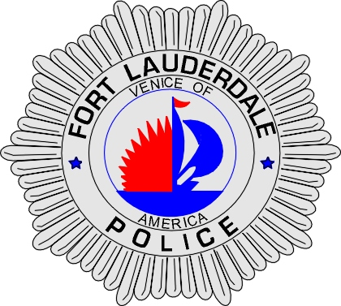 | CITY OF  FORT LAUDERDALE  POLICE DEPARTMENT  PRESS RELEASE
Sergeant Frank Sousa  Public Information Office  (954) 828-6433  FSousa@fortlauderdale.gov | CITY OF  FORT LAUDERDALE  POLICE DEPARTMENT  PRESS RELEASE | October 30, 2009
 | TRAFFIC ACCIDENT

The Fort Lauderdale Police Department is investigating a traffic crash that occurred this morning at approximately 7:52 A.M. The crash took place at the 1800 block of West Commercial Boulevard, Fort Lauderdale.

Preliminary investigation has revealed that a Broward County Transit bus was traveling westbound on West Commercial Boulevard approaching the bus stop located at the 1800 block. As the bus was stopped to unload and load new passengers, a white van driven by Daniel Christy, rear-ended the bus. The passenger of the van sustained minor injuries and was transported to Holy Cross Hospital. Two passengers from the Broward County bus were transported to Holy Cross Hospital with minor injuries also.

A D.U.I. investigation has commenced on the driver of the van Christy. At this time the investigation is on-going and continues.

Anyone with information regarding this traffic accident or who may have witnessed it is encouraged to contact the Fort Lauderdale Police Department at 954-828-5700.

###

