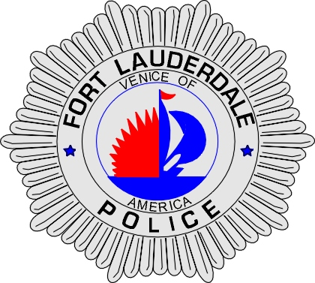 | CITY OF  FORT LAUDERDALE  POLICE DEPARTMENT  PRESS RELEASE
Sergeant Frank Sousa  Public Information Office  (954) 828-6433  FSousa@fortlauderdale.gov | CITY OF  FORT LAUDERDALE  POLICE DEPARTMENT  PRESS RELEASE | October 18, 2009
 | POLICE INVOLVED SHOOTING

Update:
The investigation into this police involved shooting is still on-going. Detectives have learned that officer’s attempted a traffic stop at the 1100 block of North Andrews Avenue. The driver refused to stop and finally came to a rest at the 1100 block of Northwest 4th Avenue. It is at that point that a confrontation ensued between the culprit and officers, escalating to the police involved shooting.

The deceased has been identified as Bastiany Georges, 02/28/1980, and a Lauderdale Lakes Resident. Bastiany Georges was released from prison in August and has an extensive arrest history.

The police officers involved in the shooting have been identified as Sergeant Jeffrey Riche. Sergeant Riche has been a police officer with the City of Fort Lauderdale since 2003. Prior to joining the City of Fort Lauderdale Officer Riche was a police officer with Plantation and a corrections officer with the Broward Sheriff’s Office. The second officer involved has been identified as Johnathan Jones. He has served the City of Fort Lauderdale since June 2008.

Sergeant Riche is still at Broward General Medical Center recovering from his gunshot wound. Officer Jones has been placed on administrative leave as per departmental policy. The investigation continues.

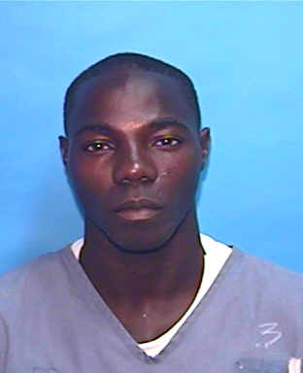
Bastiany Georges
Original:
The Fort Lauderdale Police department is investigating a police involved shooting that occurred at 1:36 A.M. The shooting took place at the 1100 block of Northwest 4th Avenue, Fort Lauderdale, FL.

Preliminary investigation has revealed that a confrontation ensued between the suspect and officers. At some point during this confrontation, shots were fired. Officers advised via police radio that shots had been fired and immediately requested for EMS to respond. A Fort Lauderdale Police Sergeant received a gunshot wound to his hand. He was transported to Broward General Medical Center where he underwent surgery and is currently resting. The suspect was also was transported to Broward General Medical center, as a result of gunfire, where he was pronounced deceased.

The circumstances leading up to the police involved shooting are still under investigation. Homicide Detectives are currently working this case and examining evidence to determine exactly what occurred.

The suspect was a black male. His identity is pending the medical autopsy.

Anyone with information regarding this shooting or who may have witnessed it is encouraged to contact the Fort Lauderdale Police Department at 954-828-5700 or Broward County Crime Stoppers at 954-493-TIPS.

###

