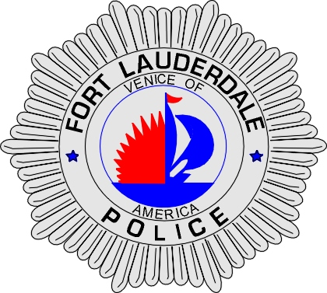 | CITY OF  FORT LAUDERDALE  POLICE DEPARTMENT  PRESS RELEASE
Sergeant Frank Sousa  Public Information Office  (954) 828-6433  FSousa@fortlauderdale.gov | CITY OF  FORT LAUDERDALE  POLICE DEPARTMENT  PRESS RELEASE | March 17, 2010
 | MISSING WOMAN

Update:
Patrol officers located Melanie Parada on Tuesday, March 16, 2010 at approximately 10:00 P.M. Melanie was located in the 1100 block of Northeast 16th Avenue, Fort Lauderdale. She was in good condition and was transported to the Fort Lauderdale Police Department.

Melanie spoke with Fort Lauderdale Detectives and was released shortly thereafter. At this time, investigators are still looking into the possibility of filing child neglect charges on Parada. This investigation continues.

Original:
The Fort Lauderdale Police Department is requesting help from the public in locating a missing 36 year-old woman.

Melanie Parada was last seen the evening of Thursday, March 11, 2010, at her residence located at 15 Isle of Venice. She was home with her 8 year-old daughter at that time. The next morning, the child woke up and discovered her mother missing. Parada has not been seen or heard from since that time. Family members reported Parada missing on Sunday after she failed to call or contact them.

Parada is described as a w/f, 5’3”, 115 lbs., blond hair, blue eyes, with a small build.

Anyone with information as to the whereabouts of this missing person is encouraged to contact the Fort Lauderdale Police Department or Detective Kathy Collins at 954-828-5548.




