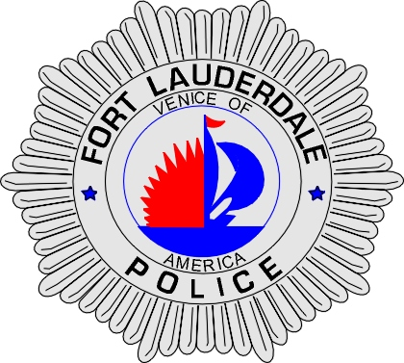 | CITY OF  FORT LAUDERDALE  POLICE DEPARTMENT  PRESS RELEASE
Sergeant Frank Sousa  Public Information Office  (954) 828-6433  FSousa@fortlauderdale.gov | CITY OF  FORT LAUDERDALE  POLICE DEPARTMENT  PRESS RELEASE | March 04, 2010
 | TRAFFIC ACCIDENT

The Fort Lauderdale Police Department is investigating a vehicle versus pedestrian accident that left the pedestrian in critical condition. The accident occurred on Wednesday, March 3, 2010 at approximately 8:04 P.M. The accident took place at Southwest 37th Avenue and Davie Boulevard.

Traffic Homicide Investigators have learned that Maurice Murphy, B/M, 11/27/1979, was operating a 2001 Toyota. Murphy was traveling eastbound on Davie Boulevard in the left thru-lane approaching the intersection of Southwest 37th Avenue. The victim, Timothy Bastian, W/M, 2/13/1970, was seen running northbound across the eastbound lanes of Davie Boulevard in the 3700 block. Bastian ran directly in front of Murphy. Murphy attempted to take evasive action; however, his vehicle struck Bastian.

Bastian was transported to Broward General Medical center where he is listed in critical condition.

The investigation into this traffic accident continues. Anyone with information regarding this accident is encouraged to contact Traffic Homicide Investigator Jill Hirsch at 954-828-5753 or Broward County Crime Stoppers at 954-493-TIPS.

###

