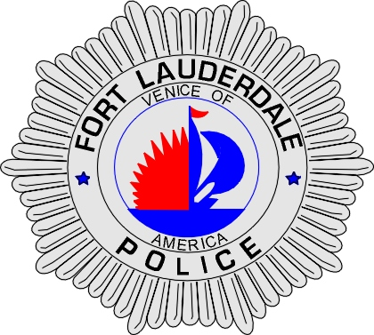 | CITY OF  FORT LAUDERDALE  POLICE DEPARTMENT  PRESS RELEASE
Sergeant Frank Sousa  Public Information Office  (954) 828-6433  FSousa@fortlauderdale.gov | CITY OF  FORT LAUDERDALE  POLICE DEPARTMENT  PRESS RELEASE | March 04, 2010
 | STRONG-ARM ROBBERY

The Fort Lauderdale Police Department is investigating a strong-arm robbery that occurred on Sunday, February 20, 2010 at approximately 10:45 A.M. The robbery took place at 1940 Cordova Road.

Preliminary investigation has revealed that the victim Theresa Lukas, W/F, 09/06/1939, was parked in a handicap spot closest to the entrance of Publix Supermarket with her husband. Lukas was approached by a white female who inquired about her upcoming back surgery. Lukas has advised police that the woman looked familiar to her, so she engaged in conversation with the suspect. The suspect told Lukas she wanted to discuss the back surgery and had Lukas enter her vehicle.

Lukas entered into the vehicle and shortly thereafter began to feel a lotion being placed onto her hand. The suspect then slid a 3 carat diamond ring, valued at $25,000, off of Lukas’ hand. The suspect then stated to Lukas that the lotion would make her feel better. Lukas began to inquire about her ring and the suspect yelled at her to get out of the vehicle. Lukas complied and the victim drove off with her ring.

It should be noted that the victim is legally blind. The suspect has been described as a white female, 5’2”, approximately 110 pounds, and brown hair. She was last seen driving a 4-door Toyota that was black or dark blue in color.

Anyone with information regarding this Robbery is encouraged to contact Detective Justin Moody at 954-828-4018 or Broward County Crime Stoppers at 954-493-TIPS.

###

