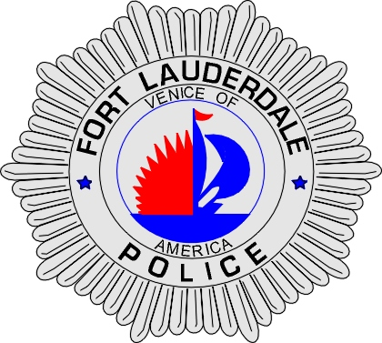 | CITY OF  FORT LAUDERDALE  POLICE DEPARTMENT  PRESS RELEASE
Sergeant Frank Sousa  Public Information Office  (954) 828-6433  FSousa@fortlauderdale.gov | CITY OF  FORT LAUDERDALE  POLICE DEPARTMENT  PRESS RELEASE | March 01, 2010
 | ACCREDITATION

The Fort Lauderdale Police Department will once again be under the scrutiny of a team of assessors from the Commission for Florida Law Enforcement Accreditation (CFA).

The team will arrive on Monday, March 9th, 2010 and will remain in Fort Lauderdale until Thursday, March 11th to examine all aspects of the Fort Lauderdale Police Department’s policies and procedures, management, operations, and support services. The Fort Lauderdale Police Department is required to comply with approximately 259 standards in order to receive accredited status. Many of the 259 standards are critical to life, health and safety issues.

The Fort Lauderdale Police Department is currently one of only 135 law enforcement agencies in Florida to have earned the state accreditation award. The Fort Lauderdale Police Department was initially accredited in 1998, and has undergone successful re-accreditation inspections in 2001, 2004, and 2007.

As part of the on-site assessment, agency members and the general public are invited to offer comments to the Commission for Florida Law Enforcement Accreditation. The comments should address the agency’s ability to comply with CFA standards. A copy of the standards is available through Public Information Officer Francis Sousa at (941) 828-6433 or at FSousa@Fortlauderdale.gov.

For more information regarding CFA or for persons wishing to offer written comments about the Fort Lauderdale Police Department’s ability to meet the standards of accreditation, please write:
CFA (Commission for Florida Law Enforcement Accreditation), 3504 Lake Lynda Drive, Suite 380, Orlando, Florida, 32817

The assessment team is composed of law enforcement practitioners from similar agencies across the State of Florida. The assessors will review written materials; interview individuals; and visit offices and other places where compliance can be witnessed.

The CFA Assessment Team Leader is Vicki Cutcliffe, formerly Director of Florida Department of Financial Services and Division of Insurance Fraud. Other team members are Retired Bureau Chief Billy Walls of the Florida Department of Environmental Protection and Lieutenant Mark Buffington of the Indian River County Sheriff’s Office.

The Accreditation Program Manager for the Fort Lauderdale Police Department is Lieutenant Patrick Hart.

Once the Commission’s assessors complete their review of the agency, they report back to the full Commission which will then decide if the agency is to receive accredited status in Bonita Springs, FL on Thursday, July 1st, 2010. The Fort Lauderdale Police Department’s accreditation award is for 3 years. Verification by the team that Fort Lauderdale meets the Commission’s standards is part of a voluntary process to gain or maintain accreditation a highly prized recognition of law enforcement professional excellence.

###

