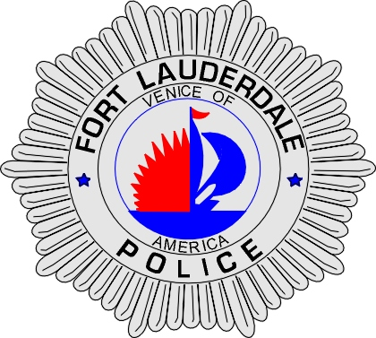 | CITY OF  FORT LAUDERDALE  POLICE DEPARTMENT  PRESS RELEASE
Sergeant Frank Sousa  Public Information Office  (954) 828-6433  FSousa@fortlauderdale.gov | CITY OF  FORT LAUDERDALE  POLICE DEPARTMENT  PRESS RELEASE | September 28, 2009
 | COMMERCIAL VEHICLE INSPECTION CHECKPOINT

The Fort Lauderdale Police Department will be conducting a commercial vehicle inspection checkpoint on Tuesday, September 29, 2009. The checkpoint will be held at the 900 block of West State Road 84. The checkpoint will be conducted from 7:00 A.M. until 11:00 A.M.

Vehicles will be randomly selected and drivers will be checked for valid paperwork and driver’s license. Officers will also be conducting safety inspections on checked vehicles. The police department does not anticipate any traffic delays because of this operation.

###

