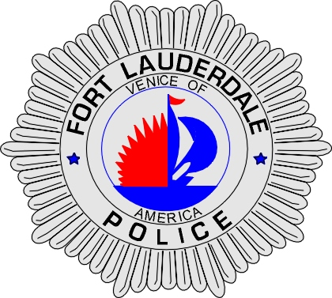 | CITY OF  FORT LAUDERDALE  POLICE DEPARTMENT  PRESS RELEASE
Sergeant Patrick Hart  Public Information Office  (954) 828-5642  Path@fortlauderdale.gov | CITY OF  FORT LAUDERDALE  POLICE DEPARTMENT  PRESS RELEASE | September 30, 2009
 | TRAFFIC HOMICIDE INVESTIGATION

The Fort Lauderdale Police Department is investigating a traffic crash that occurred at approximately 4:38 p.m. at Northeast 20th Avenue and East Commercial Boulevard.

Preliminary investigation has revealed that the victim was walking northbound across East Commercial Boulevard at the intersection of Northeast 20 Avenue. Nathalie Affiany was operating a 2004 Volkswagon, white in color. Affiany was traveling northbound on Northeast 20 Avenue approaching the intersection of East Commercial Boulevard. Affiany made a left turn to travel westbound on East Commercial Boulevard. The victim then traveled into the path of Affiany’s vehicle. Affiany’s vehicle struck the victim. The victim was transported to Broward General Medical Center with life threatening injuries.

The Victim has been identified as Judith Testa, W/F, 05/16/1938, and a Fort Lauderdale resident. Affiany was not injured in the crash.

Anyone with information regarding this accident of who may have a witnessed it is encouraged to contact Traffic Homicide Investigator Jill Hirsch at 954-828-5753 or Broward County Crime Stoppers at 954-493-TIPS.

###

