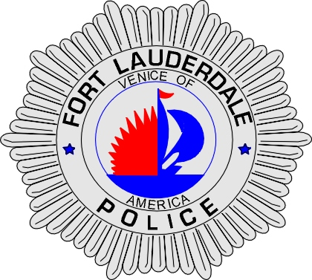 | CITY OF  FORT LAUDERDALE  POLICE DEPARTMENT  PRESS RELEASE
Detective Kathy Collins  Public Information Office  (954) 828-5548  kcollins@fortlauderdale.gov | CITY OF  FORT LAUDERDALE  POLICE DEPARTMENT  PRESS RELEASE | September 2, 2009
 | BURGLARY

Update:
Detectives Sean Reddish and Scott Neily aggressively investigated the burglary and arson which resulted in a loss in excess of $175,000 in cash. Today, detectives interviewed an employee, Julio G. Gamez, 3/30/1987, who had been working the previous evening. During the interview, Gamez admitted to his role in the theft and arson and named his accomplice, his roommate, Eduardo Aguilar, 7/4/1978. Additionally, Gamez led detectives to his residence in Pembroke Pines where they located over $161,000 in cash, belonging to the check cashing store.

Julio G. Gamez and Eduardo Aguilar were arrested and charged with Arson and Grand Theft.

Original:
The Fort Lauderdale Police Department is investigating an overnight burglary that occurred at 6303 Northwest 9 Avenue. The burglary occurred at the American Quick Cash Checking Store.

Preliminary investigation has revealed that the Fort Lauderdale Police Department received a telephone call from an employee this morning at approximately 6:55 A.M. The employee stated that smoke was coming from inside the business. Fort Lauderdale Police and Fire Rescue responded to the store. The fire department was able to extinguish a small fire. Upon entering the business, police discovered that it had been burglarized.

An unknown amount of suspects entered the business and burglarized the safe inside of the business. It appears that tools were used to open the safe and this may have caused the fire to start. There is no video surveillance available of this incident. At this time, the total loss is unknown.

The police are seeking any possible witnesses or anyone who may have information regarding this event to please contact Detective Sean Reddish at 954-828-5676 or Broward County Crime Stoppers at 954-493-TIPS.

###

