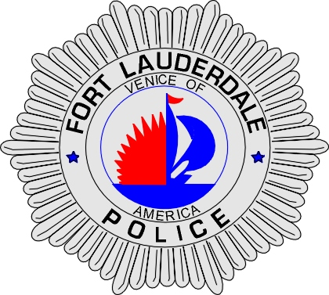 | CITY OF  FORT LAUDERDALE  POLICE DEPARTMENT  PRESS RELEASE
Sergeant Frank Sousa  Public Information Office  (954) 828-6433  FSousa@fortlauderdale.gov | CITY OF  FORT LAUDERDALE  POLICE DEPARTMENT  PRESS RELEASE | September 2, 2009
 | AGGRAVATED BATTERY ON A LAW ENFORCEMENT OFFICER

The Fort Lauderdale Police Department arrested Corinthian Johnson, B/M, 12/16/1993, on several charges last night. Those charges include Aggravated Battery on a Law Enforcement Officer and Fleeing and Eluding the Police. Johnson faces more charges in connection with an Armed Carjacking from Aventura and an Armed Robbery and Kidnapping from Hollywood.

Detectives have learned that on August 28, 2009, Johnson committed an Armed Carjacking in the City of Aventura, where a black BMW SUV was taken. A short time later Hollywood Police received reports of an Armed Robbery and a Kidnapping matching the same description as the carjacking in Aventura.

On September 1, 2009 Fort Lauderdale Detectives located the black BMW, which was taken in the carjacking. A vehicle pursuit ensued and was terminated. Information was developed on the whereabouts of the Johnson. Surveillance was established by Fort Lauderdale Officers and Detectives. At approximately 2145 hours, officers observed the vehicle. A traffic stop was initiated. Johnson rammed into a Fort Lauderdale Police Detective’s unmarked vehicle at Northwest 17th Terrace and Oakland Park Boulevard. Johnson continued to drive and eventually rear ended another police vehicle at Northwest 21 Avenue and Northwest 24 Street. Officers were finally able to get the suspect to stop and take him into custody.

At this time, Fort Lauderdale Police Detectives are working with investigators from the Aventura Police Department and Hollywood Police Department. Hollywood and Aventura will be adding additional charges to Johnson. Anyone with information regarding this incident is encouraged to contact Detective Richard Rivera at 954-828-6355, Detective Jason Wood at 954-828-5344, or Broward County Crime Stoppers at 954-493-TIPS.
###

