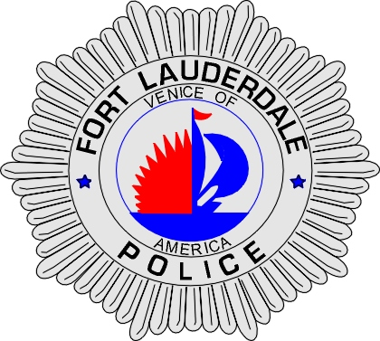 | CITY OF  FORT LAUDERDALE  POLICE DEPARTMENT  PRESS RELEASE
Sergeant Frank Sousa  Public Information Office  (954) 828-6433  FSousa@fortlauderdale.gov | CITY OF  FORT LAUDERDALE  POLICE DEPARTMENT  PRESS RELEASE | September 18, 2009
 | UNKNOWN DEATH

On September 10, 2009, the Fort Lauderdale Police Department responded to the area of Interstate 95 and Davie Boulevard in reference to reports of a body being found. On arrival, officers located a deceased body and initiated a death investigation.

Investigation has revealed that the victim, Paul Gary Innamorato, W/M, 12/12/1955 was visiting Fort Lauderdale. Innamorato was staying at the Marriott Harbor Beach Hotel located at 3030 Holiday Drive on July 16, 2009. On that date, the victim left for a walk at approximately 6:30 P.M. wearing a green polo shirt, swim trunks with blue trim, and black flip flop sandals. The victim never returned from his walk and a missing person report was filed.

Mr. Innamorato’s body was recovered on Thursday, September 10, 2009. The police department is requesting anyone who might have seen Mr. Innamorato or who has information about his death to please call Detective Jim Jaggers at 954-828-5970 or Broward County Crime Stoppers at 954-493-TIPS.

###

