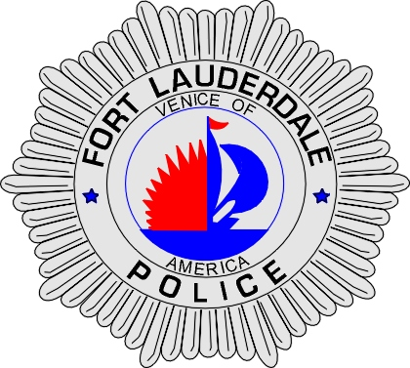 | CITY OF  FORT LAUDERDALE  POLICE DEPARTMENT  PRESS RELEASE
Sergeant Patrick Hart  Public Information Office  (954) 828-5642  Path@fortlauderdale.gov | CITY OF  FORT LAUDERDALE  POLICE DEPARTMENT  PRESS RELEASE | August 17, 2009
 | ARMED ROBBERY ARREST

The Fort Lauderdale Police Department is investigating an armed robbery that occurred on 8/16/09 at approximately 2149 hours. The robbery took place in the 3400 block of NE 33 Ave, Ft. Lauderdale, Florida.

Preliminary investigation revealed the victim, 71 years of age, was robbed at gun point at approximately 2149 hours. The victim was walking to his vehicle when he was approached from behind by a white male, with his face covered by a t-shirt. The white male pulled out a black hand gun, chambered a round and pointed it at the victim. The white male demanded that the victim’s wallet and the victim complied. The white male got into the passenger side of a 2 door silver Honda. The vehicle fled in a south bound direction.

The vehicle was spotted by an on-duty officer in the 1300 block of E. Sunrise Blvd, Ft. Lauderdale, Florida. A felony stop was attempted prior to getting onto I-95. The vehicle refused to stop and a pursuit was initiated. The pursuit came to a stop approximately one mile south of Woolbright Road on the side of I-95. The occupants bailed out of the vehicle and attempted to flee on foot while on I-95. The initiating officer and Ft. Lauderdale Police K-9 officers took both male subjects into custody. A female subject fled into a wooded area and hid in a canal. The female subject was later located by the Ft. Lauderdale Police K-9 officers and taken into custody. A firearm was recovered from the suspect’s vehicle, along with a portion of the victim’s property.

The subjects that are in custody are Kyle Smith, W/M, 10/29/86, Ivan Camacho, W/M, 1/19/85. The white female juvenile was later released. Both subjects were charged with armed robbery and resisting arrest without violence.

The Ft. Lauderdale Police Department would like to thank the following agencies for their assistance: Broward Sheriff’s Office, Boynton Beach Police Department, Del Ray Police Department and the Palm Beach Sheriff’s Office.

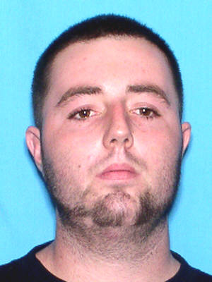
Kyle Smith, W/M, 10/29/86

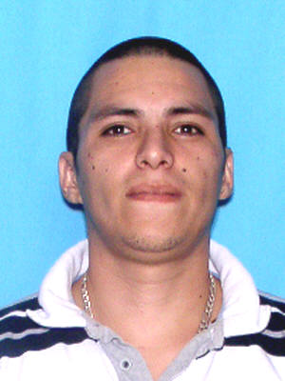
Ivan Camacho, W/M, 1/19/85

###

