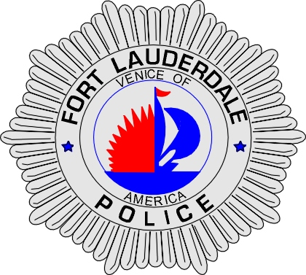 | CITY OF  FORT LAUDERDALE  POLICE DEPARTMENT  PRESS RELEASE
Sergeant Frank Sousa  Public Information Office  (954) 828-6433  FSousa@fortlauderdale.gov | CITY OF  FORT LAUDERDALE  POLICE DEPARTMENT  PRESS RELEASE | July 30, 2009
 | TRAFFIC SAFETY CHECKPOINT

The Fort Lauderdale Police Department will be conducting a traffic safety checkpoint on Friday, July 31, 2009. The checkpoint will be held at the 1200 block of Northwest 6 Street. The checkpoint will be conducted from 2:00 P.M. until 2:00 A.M.

Vehicles will be randomly selected and drivers will be checked for valid paperwork and driver’s license. Officers will also be conducting safety inspections on checked vehicles. The police department does not anticipate any traffic delays because of this operation.

###

