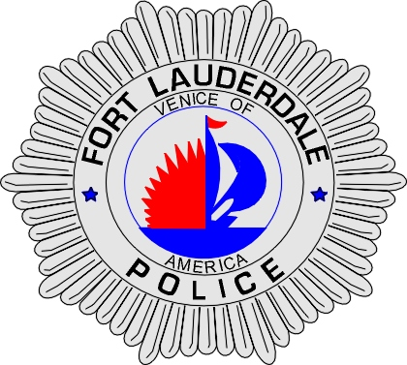 | CITY OF  FORT LAUDERDALE  POLICE DEPARTMENT  PRESS RELEASE
Sergeant Frank Sousa  Public Information Office  (954) 828-6433  FSousa@fortlauderdale.gov | CITY OF  FORT LAUDERDALE  POLICE DEPARTMENT  PRESS RELEASE | July 13, 2009
 | TRAFFIC FATALITY

Update:

The victim has been identified as Alvin Grant, B/M, 03/25/1973, and a Sunrise resident.

Original:
The Fort Lauderdale Police Department is investigating a traffic fatality that occurred at approximately 9:35 P.M. in the 1000 block of West Sunrise Boulevard.

Preliminary investigation has revealed that a 2004 Toyota Scion, operated by Mia Reynolds, was driving eastbound on West Sunrise Boulevard approaching the 1000 block. The victim was operating a 2007 Honda motorcycle. The victim was traveling westbound on West Sunrise Boulevard approaching the 1000 block.

Reynolds proceeded to make a left turn to travel northbound on Northwest 10th Avenue. The front of the motorcycle struck the right front of Reynolds’s vehicle. The victim was transported to Broward General Medical Center with life threatening injuries.

The victim was pronounced deceased at the hospital. His identity is being held until we are able to notify his next of kin.

Anyone with information regarding this accident or who may have witnessed it is encouraged to contact Traffic Homicide Investigator Jill Hirsch at 954-828-5753 or Broward County Crime Stoppers at 954-493-TIPS.

###

