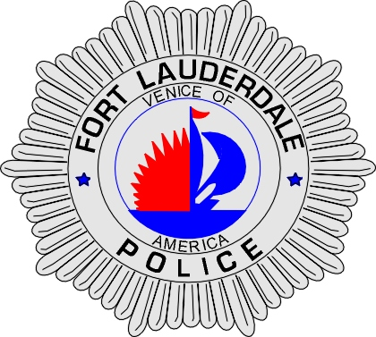 | CITY OF  FORT LAUDERDALE  POLICE DEPARTMENT  PRESS RELEASE
Sergeant Frank Sousa  Public Information Office  (954) 828-6433  FSousa@fortlauderdale.gov | CITY OF  FORT LAUDERDALE  POLICE DEPARTMENT  PRESS RELEASE | July 21, 2007
 | BOATING UNDER THE INFLUENCE

The Fort Lauderdale Police Department received a telephone call on July 20, 2009 at approximately 11:15 P.M. in reference to a burglary in progress occurring at 331 Lido Drive, Fort Lauderdale. The caller indicated that there were two males at her residence jiggling on the rear door, attempting to open it. The caller stated that the men were talking to each other and she could not make out what was being said.

Fort Lauderdale Police and K-9 officers were dispatched to the location and a perimeter was established. Upon arrival, officers discovered a white male later identified as Patrick Stewart on the property. Stewart was detained as officers continued their burglary investigation.

Once Stewart was detained, Officers observed another white male later identified as Robert Ray Huizenga operating a 2005 Jupiter Marine vessel. Officers asked Huizenga to throw them a rope so the boat could be secured to a dock and their investigation could continue. Huizenga attempted to throw a rope several times and was unsuccessful in his attempts. After several attempts, officers were able to grab the rope.

Contact was made with Huizenga and he was asked to exit the boat. Officers immediately detected that Huizenga had a strong odor of alcohol emanating from his person. Huizenga stated to the officers that he was at his residence when in fact he was not. Officers also detected that Huizenga had slurred speech when he spoke to them. Suspecting that Huizenga was under the influence of alcohol, officers requested a member of Broward County Sheriff’s Office D.U.I. Task Force to respond to our location.

A D.U.I. Task Force Deputy arrived on scene and conducted an investigation. After his investigation was completed, Robert Huizenga was taken into custody for Boating under the Influence. He was also charged with Refusal to submit to a BUI test, Violation of Probation for Felony D.U.I., and Violation of Probation for failure to submit to a sobriety test.

Patrick Stewart, 03/24/1965, was charged with Trespassing, Possession of a Schedule 4 Controlled Substance, and Possession of Cannabis under 20 grams.

Huizenga and Stewart were transported to the Broward County Main Jail and this investigation is on-going. Anyone with information regarding this event is encouraged to contact the Fort Lauderdale Police Department at 954-828-5700 or Broward County Crime Stoppers at 954-493-TIPS.

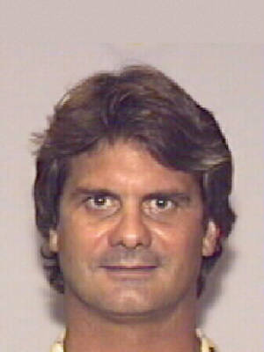
Robert Ray Huizenga

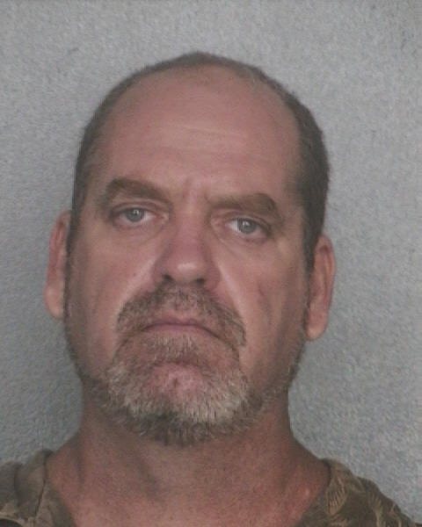
Patrick Stewart
###

