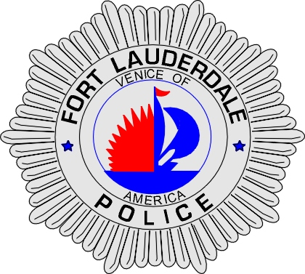 | CITY OF  FORT LAUDERDALE  POLICE DEPARTMENT  PRESS RELEASE
Sergeant Frank Sousa  Public Information Office  (954) 828-6433  FSousa@fortlauderdale.gov | CITY OF  FORT LAUDERDALE  POLICE DEPARTMENT  PRESS RELEASE | March 01, 2010
 | ACCIDENTAL DEATH

On Sunday, February 28, 2010, patrol officers responded to 1112 Northwest 18th Court in reference to reports of a man being electrocuted. Officers responded to this location at approximately 11:47 A.M.

Upon arrival, officers located the victim to the rear of the residence on the ground. Fort Lauderdale Fire Rescue Units arrived on-scene and pronounced the victim deceased.

Investigators have learned that the victim was in a tree attempting to set-up a radio frequency to communicate with Haiti. As a wire was being fed to the victim, he accidentally touched a live electrical power line. This caused the victim to electrocute himself and he fell from a tree to the ground.

The victim has been identified as Mackenson Mareus, B/M, 11/22/1982, and a Lauderdale Lakes resident.

Anyone with information regarding this death is encouraged to contact Detective Ghalib Carmichael at 954-828-5521 or Broward County Crime Stoppers at 954-493-TIPS.

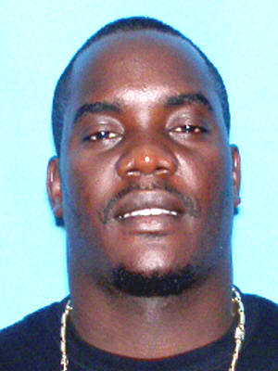
Mackenson Mareus

###

