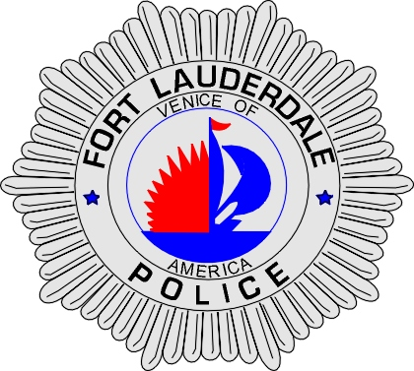 | CITY OF  FORT LAUDERDALE  POLICE DEPARTMENT  PRESS RELEASE
Sergeant Frank Sousa  Public Information Office  (954) 828-6433  FSousa@fortlauderdale.gov | CITY OF  FORT LAUDERDALE  POLICE DEPARTMENT  PRESS RELEASE | February 23, 2010
 | Robbery
***VIDEO IS AVAILABLE***

The Fort Lauderdale Police Department is investigating a strong-arm robbery that occurred on Wednesday, February 10, 2010 at approximately 10:30 P.M. The robbery took place at the Seven-Eleven located at 1529 East Las Olas Boulevard.

Detectives have learned that the victim, Michael Diamond, a Fort Lauderdale resident, 4/15/1939, was approached by the suspect as he left the store. The suspect asked Diamond if he could have a few dollars. Diamond agreed to help the suspect. As Diamond pulled out his wallet, the suspect grabbed his wallet and forcibly pushed Diamond to the ground. The suspect took off on foot westbound from the store.

The suspect has been described as a W/M, 6’2”, 165 pounds, wearing all black clothing. He also has a large tattoo on the left side of his neck.

Anyone with information regarding this incident is encouraged to contact Detective Elijah Thomas at 954-828-6093 or Broward County Crime Stoppers at 954-493-TIPS.






