 | CITY OF  FORT LAUDERDALE  POLICE DEPARTMENT  PRESS RELEASE
Sergeant Frank Sousa  Public Information Office  (954) 828-6433  FSousa@fortlauderdale.gov | CITY OF  FORT LAUDERDALE  POLICE DEPARTMENT  PRESS RELEASE | January 29, 2010
 | AGGRAVATED BATTERY
***Photo’s on Page 2***

The Fort Lauderdale Police has completed an investigation into an aggravated battery, which is also being handled as a hate crime.

On September 6, 2009, police officers responded to 2111 Northeast 56 Street in regards to a battery. Officers contacted the victim, who advised that he went to his neighbor’s home, because there were people yelling and the music was loud. The victim was confronted by Ricardo Rivera and a verbal argument ensued. The argument escalated and Rivera began physically striking the victim, causing the victim to fall to the ground. While the victim was being struck, Rivera used slurs against the victim’s sexual orientation. The victim then retreated back to his apartment and waited for the police.

A few days later the victim was still experiencing pain from his shoulder area that was a result of his fall. The victim sought medical treatment and discovered that he had torn his rotator cuff.

On September 7, 2009, the victim observed Rivera’s vehicle in the parking lot. The victim wanted to obtain the tag number to update his police report from the previous altercation. As he was recording the tag number, Bedsaida Rivera, approached the victim and began to spray him in the face with pepper spray. Bedsaida continuously pepper sprayed the victim while shouting derogatory slurs about his sexual orientation.

Detectives were assigned to handle the investigation into these incidents. A Fort Lauderdale Special Victims Detective obtained arrest warrants for both Bedsaida and Ricardo. Bedsaida was arrested on January 12, 2010 and charged with Simple Battery. Ricardo was arrested in Georgia on January 27, 2010 and charged with Aggravated Battery.

This case is being handled as a hate crime and both Bedsaida and Ricardo now face enhancements of their charges because of the evidence of bias motivation towards the victim because of his sexual orientation.
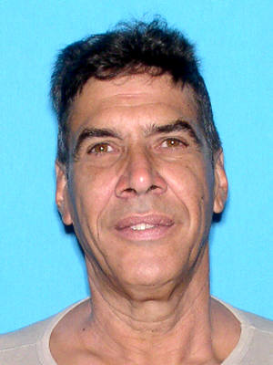
Ricardo Rivera

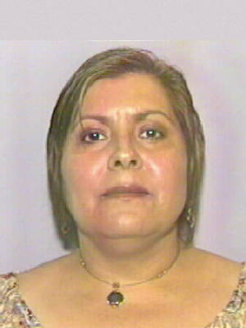
Bedsaida Rivera
###

